World Triathlon Championships, Auckland 22/10/2012

Swim familiarisation practise

I came into the World Triathlon Championship full of confidence from my silver medal in the Aquathlon. I had exceeded my expectations there, and am normally likely to do better in a triathlon- with both bike and run to catch up any ground lost in the swim! However I also knew the competition would be tougher. This was the main event, after all, and not everyone had raced the aquathlon only 5 days beforehand. I would have to see if I had recovered enough!
Auckland had enjoyed gale force winds and rain ever since the Aquathlon, which made recce-ing the bike course quite a challenge just to stay upright. It was a relief to wake up on race day to sunshine, and though the wind was still strong at least it had died down.
The pre-start was a lot more stressful, being held in waiting pens until it was time for our wave, just wanting to get on with it! Once in the water, I had another good start and avoided being swum over- so far, so good. However once out of the shelter of the harbour, we had the waves and tide to contend with, and sighting became a real issue. The organisers choice of small red buoys about 400m apart was not ideal. I literally couldn't see anything to head towards and no choice but to follow the swimmers in front... Who seemed to be heading towards any floating objects (which later turned out to be safety canoes) and in completely the wrong direction. I kept looking up but couldn't see anything, and started to worry. Minutes passed before I saw the buoy- about 90 degrees from the direction I was heading! I felt sick at that point about how much extra I must have swum and how much time lost, but I certainly wasn't the only one. Spectators later said the tide had turned during our wave and swept a lot of people off the course.
Nothing I could do at that point but see what I could catch up on the bike and run!
The bike course had a bit of everything - a few hills and descents, a few technical corners and dead turns. The main part of the course was a long, flat TT section along exposed coastal roads. I’m pretty happy on most bike courses and this one was no different- except that at race speed, the wind was so strong I was battling just to stay upright on the aero Twinfoil, with only 49kg of me to hold it down!

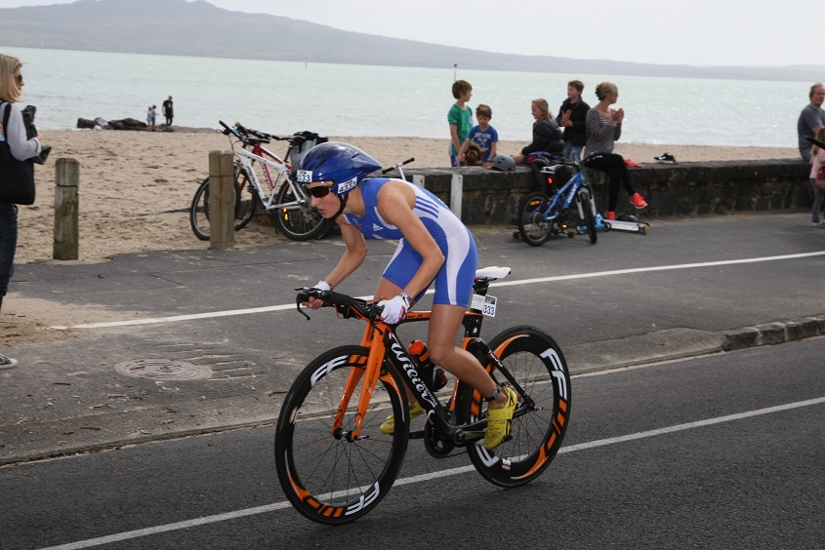
Bike course
While my power:weight ratio is not bad, I am not a pure power athlete, it was hard going into the 25kmph headwind. This type of condition is not to my advantage against much bigger and stronger girls on a mainly flat course. I had no choice but to give it everything on the bike and try and regain ground lost on the swim. I was rewarded with one of the best bike splits and picked up a lot of places, but the top girls were still extending their lead…
I may be a good runner, but catching up more than about 5 minutes over 10k was probably not going to be possible - especially as the run course was fast and flat. It would not slow the weaker runners down too much... I also wondered how much my own legs had suffered after the effort put in on the bike...
I still had no idea what position I was in or how many minutes behind I was - no information was available. So it was just the usual strategy of overtaking as many people as I could. I was aware my legs were starting to cramp though; I’d just have to concentrate on keeping good form…
I managed the first 5k in a reasonable 18:25, however cramp really struck on the second lap and I felt like I was hobbling in places. Amazingly I was still passing people all the way, although not at the rate I hoped. I was reduced to almost 20 minutes for the second 5k, and was just looking forward to the finish chute now, even though I suspected I hadn’t quite run into the podium places.
I crossed the line to be announced as 7th place in 30-34 category, although I was a bit disappointed I had to accept on the day I couldn’t have done more. The British girls had a fantastic day in 30-34 age group, with the Gold medal going to Laura Siddall and Bronze to Anna Turvey (plus Stacey Penn winning the sprint distance in our category earlier that morning). With the Kiwis and Aussies dominating most of the other categories, I was happy to finish 3rd Brit overall across all age groups.

