World Duathlon Championships, Nancy, France 23/09/2012

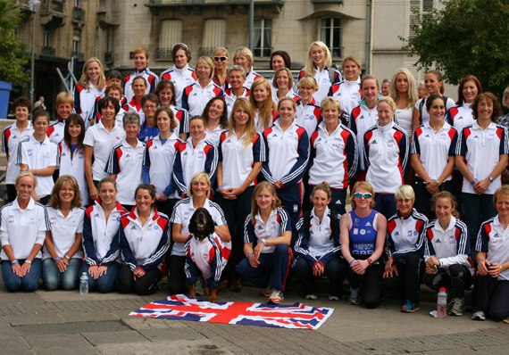
GB Women’s Team

I travelled to Nancy in France with high hopes for the World Duathlon Championships - I was the returning silver medallist in my age group from Spain last year. I was also hoping to top my 5th place overall finish from 2011. This year’s course was very different and would play to different people’s strengths, so only race day would tell!
This was very much a runner’s course with the run being long and the bike almost 3km short. There were no big hills on the bike either, which would normally be an opportunity to take chunks of time out of the weaker riders. That said it was a very technical town course with dozens of sharp corners, dead turns, and some narrow S-bend descents on each of 5 laps. Poor bike handlers would lose a lot of time here, and I definitely predicted some crashes!
I had crashed myself, when the European Champs were held here in 2010 - a sudden downpour lifted a layer of diesel onto the road during the women’s race making the dead turns suddenly lethal. Despite this I had still ridden the 2nd fastest bike split of the day - so it should be a course that suited me.
Thankfully this year race day was dry, and I was psyched up and ready to go for the 10km run. I took position at the front on the start line, and set off hard, but at a pace I should be able to sustain. However it soon became apparent that my legs were not their usual springy selves today. I was not able to hold the pace I know I am capable of - I would just have to hold on as much as I could and see what I could pull back on the bike.
I was 9th in my wave coming off the run, gained another 2 places in transition, and once aboard the Twinfoil, it was time to start overtaking people! I found myself zipping past other athletes on all the technical sections, sometimes as if they were standing still! I even had cheers from some enthusiastic Americans for my “great cornering”! I never thought of myself as a great technical rider, but the daily commute through Reading traffic certainly seems to have paid off in bike handling skills. Skills which also helped me avoid fallen athletes and medics in the predicted crashes!
There were some good time-trialers out there however, they clawed back time on the flat straight sections, and in some technical parts there was no option but to pull the brakes on as the course was very narrow and slower athletes from previous waves were blocking the way. I wouldn’t want them to take me out by taking a corner poorly and coming off their line.
But the net effect by the time we hit T2, I had moved up about 5 places. I wished we had another lap so I could put some more time between the better runners! As it was, I would have to see how many I could hold off on the final run… My second run felt better than the first, and I managed to hold off all except 2 who I’d overtaken on the bike. I finished 5th in my category which to be honest was pretty disappointing after a silver medal last year.
The full results showed a better picture, I had finished 9th overall across all of the age groups. I would have been easily within the medals for any other category. Unfortunately half the top athletes just happened to be 30-34 (11 of the top 22 finishers), but that is the age group lottery….

