World Aquathlon Championships, Auckland 17/10/2012

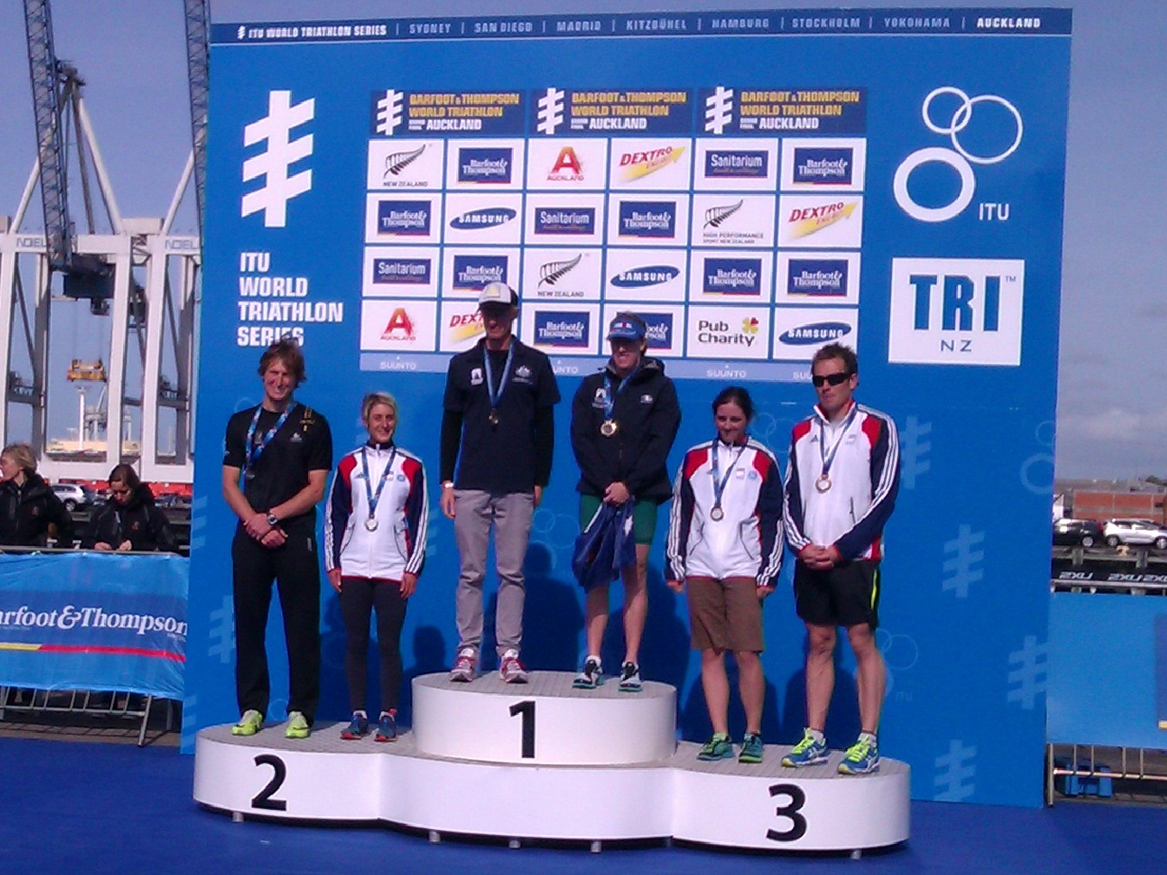
30-34 Podium (Silver medal for Louise)

I entered the World Aquathlon Championship primarily as a warmup for the World Triathlon, which took place 5 days later. It would be a good chance to check out the course and conditions, as well as some of the opposition. I was not expecting to be on the podium, especially as the distances were weighted too much towards the swim for my liking!
The race was less than 48 hours after landing from my 30-hour flight from London. I had no idea how my body would respond to such a journey, but in the worst case I hoped at least it would shock the jet lag out of my system in time for the triathlon!
All women were set off across just 2 waves, meaning a very crowded and ‘physical’ swim. I managed to get a good start off the pontoon, and had clear water until close to the first buoy. However at this point the field converged; I was being swum into – sometimes over- from all angles, and lost ground a couple of times when people pulled me back by the ankles. Frustrating when others decide to play unfair, but you just have to keep calm and keep going!
Soon we left the shelter of the harbour for the open sea - which was unexpectedly rough, much tougher conditions than the practise swim the day before. The bow waves of passing ships didn’t help either, plus the salt becomes a problem if you swallow too much. A number of athletes were sick during the swim or later on the run. It was too much for some who had to be picked up by rescue boats. Thankfully for me, the challenging conditions broke up the pack and I could finally relax with clear water again.
The swim was a relatively long 1km compared to the standard 750m in UK aquathlons. Sadly the run was still only 5k; since running is my stronger event, the longer the run, the more people I have chance to catch and pass. Unfortunately I started off by passing my shoes in transition - not as easy to spot as a bright orange bike! I probably only lost 10 seconds but it always feels like more.
Once out on the run though, this is where I started properly enjoying myself and overtaking better swimmers by the dozen. I would have happily carried on for a second 5k! From 57th position on the swim, I managed to move up into 11th place overall, with the fastest run in my category by over a minute!
Most significantly, I was the fastest Brit overall. It was the first time I have managed this in an international championship! I had no idea where I was in the field until I crossed the line, so I was delighted to be announced as silver medallist in the 30-34 category. I found out later I had beaten some of the elite athletes as well, and my 17:30 run split was 2nd fastest overall - significantly faster than all of the elite women.

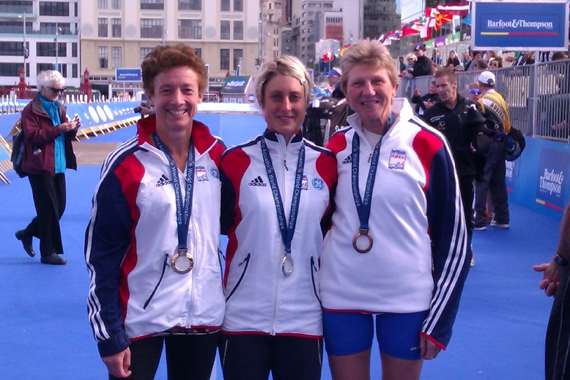
GB Medallists Caroline Whittaker (1st 50-54), Louise Bardsley (2nd 30-34) and Bev Childs(3rd 55-59)

