Steyning Sprint Triathlon – 6th May 2012

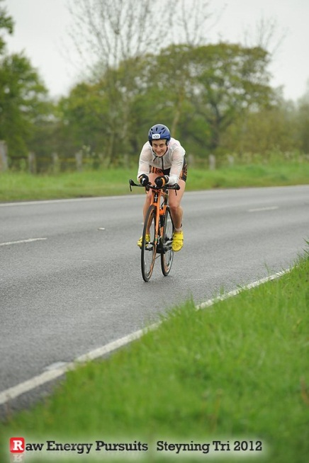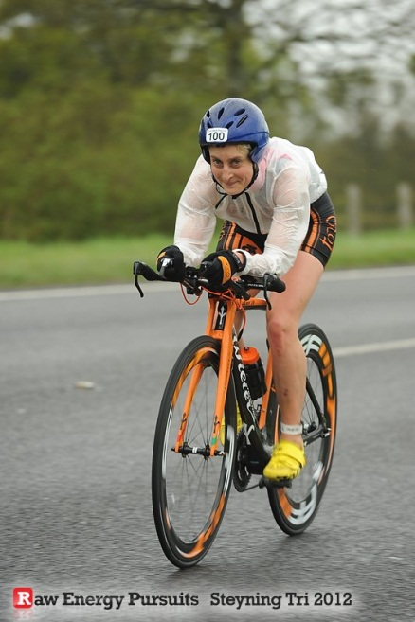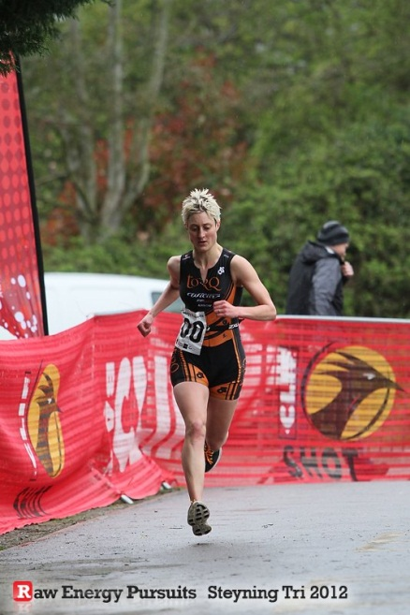
The Steyning Sprint was my first Triathlon of the year, my first for Team TORQ, and my first time out on the eye-catching TORQ-ed up Wilier Twinfoil.
It was a great confidence boost to win the Women’s race by almost 4 minutes, and in fact only get beaten by 6 men! The organisers, Raw Energy Pursuits, described it as the most impressive performance of the day - a nice accolade to have given that it was only one of four races!
The day did not begin in such a positive manner when we woke up to see persistent-looking rain, and temperatures of around 5 or 6 degrees. Still - I reminded myself - these were pretty much the conditions most of us have been training in all spring!
On the start line I was fairly nervous - the swim was an unknown quantity for me as I hadn’t raced in a pool for 2 years. In fact I hadn’t done any swim racing since my last tri in September. I was interested to see if all of my winter work in the pool and gym had paid off. Indeed it had - I was very happy to knock a chunk off my PB with a split of 6:10 for 400m; giving me the fastest ladies swim of the day. Also the first time for me to get the fastest swim split in a race!
Like most people, I had a relatively slow T1 as I needed to put on a jacket and gloves. Definitely a good call though as I just about managed to stay warm on the bike! I was eager to see how the Twinfoil fared on its maiden voyage – mainly I was hoping the ‘engine’ would live up to the hype! The bike was certainly attracting a lot of attention in transition, and got a compliment over the PA system as I headed out onto the course! Unfortunately it/I had to stop to allow a car to pass before taking the first right turn. I hadn’t even managed to get my feet in my shoes. Minor delay aside it was soon up to high speed.
The bike route was a perfect TT course for a test run, taking in a series of undulating main roads; with nothing more technical than two turnaround roundabouts. (A few tweaks to the setup here and there and hopefully it will get even faster!)
Once off the bike (via a minor deviation - going the wrong way into transition - and after wrestling off my wet bike jacket) it was on to my favourite part of the race - the run. Triathlon running seems so much less painful than the second run of a Duathlon! The course was a reasonably hilly and twisty route through the centre of the village of Steyning, which suited me well. This was my best element of the day with a run time almost 3 minutes clear of the second fastest lady.
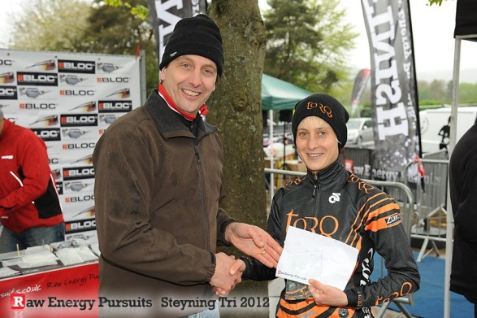
It was a great feeling crossing the finish line with the announcer saying that I had broken the hour and taken the lead in the womens’ race.

