National Duathlon Championships – Dambuster 2012

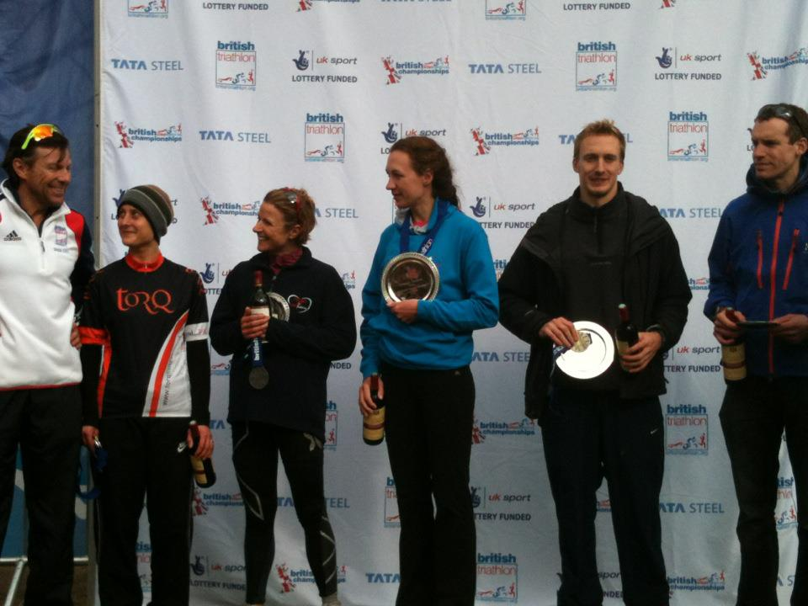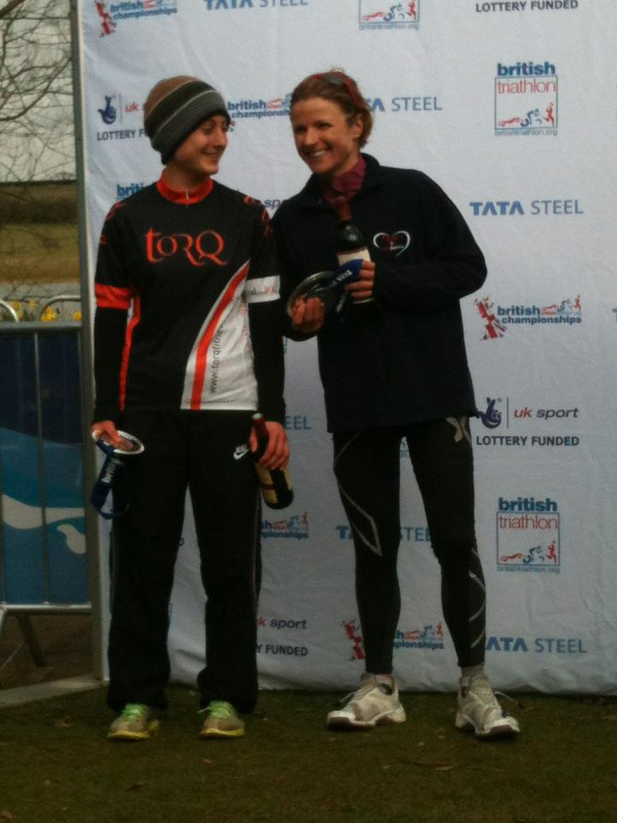
  - Winners 30-34 Age Group 3rd & 2nd Overall (Louise & Amy)

The National Duathlon Championships – Dambuster – was my first ‘A’ race of the 2012 season.
My training had gone well this winter, so I was hoping to improve on my 5th place overall in the Nationals last year at Clumber Park.
It was to be another exciting race- with less than a minute separating the top three women - but would I be among them?
On the night before the race, I would have said “no chance” – as despite my best laid plans for preparation, some things lay inevitably outside my control!
After a tough week in work, late evenings doing emergency DIY, and feeling like I was coming down with the illness currently circulating the office, I was feeling run down and apprehensive to say the least.
Thankfully my bike mechanic, aka fiancé, had persuaded me back in November to book a more expensive hotel which was only 2 miles from the start. This turned out to be money well spent since the hotel had a pool and spa - just what the doctor ordered to de-stress from the drive, get rid of a headache and facilitate my first decent night’s sleep of the week.
Normally I can never sleep on race night; I must have been *really* tired! Thankfully this meant I woke up on race morning feeling much more human…
In fact, by the time I’d warmed up - with some motivational tunes on the headphones - I was feeling quite up for the race, and actually got off to a flying start with a PB in the 10k (36:50). I entered T1 in second place, and the fastest T1 of the day saw me exit as first lady on the bike – a position I have never been in before!
On one hand this was great, but on the other I realised I had no idea how to ride when there was no-one ahead of me to chase down!
I held the lead for around 30k of the 43k bike course, then the week’s tiredness began to take effect; this coincided with getting caught in some bad traffic. Half a dozen cars were causing 20-odd bikes to bunch up, and tensions were fraying as cars and bikes tried to overtake each other on some fast downhill corners. I’ve had too many crashes to take any more risks in these situations, and frustrating though it was, I made the choice that I’d rather concede 30 seconds braking at the back of the pack, than risk a collision.
Unfortunately this meant the couple of girls who had closed down on me, overtook and got away. I didn’t have the speed to close the gap once the traffic had gone. Definitely something to work on for the next race…
I entered T2 in 3rd place, and managed to hold this for the final 5k run to take 3rd place overall.
I was pleased with my 5k run time of 18:03 as I was not feeling great at all by this point. I was glad to make it to the finish with a creditable performance and my best result to date at the National Duathlon Championship.

