Castle Combe Chilly Duathlon

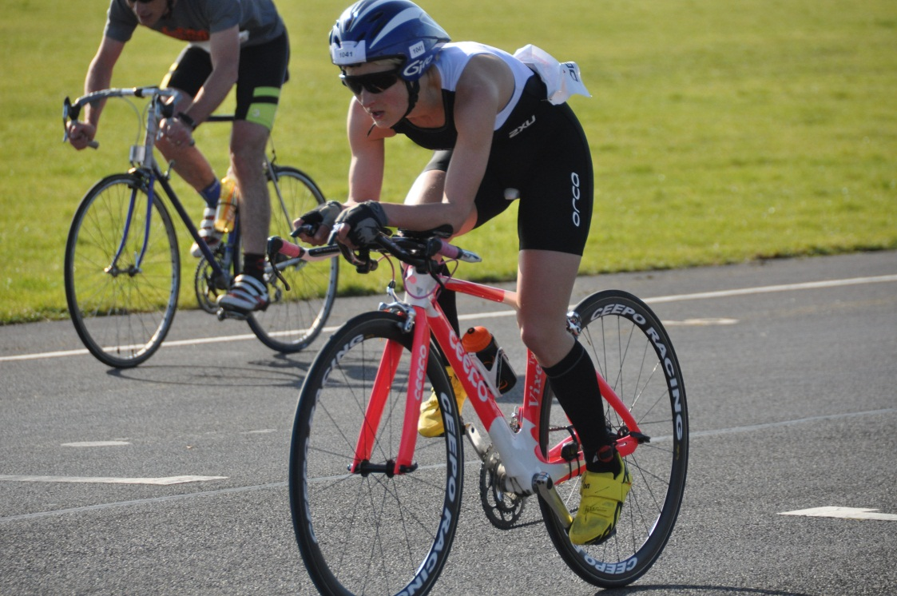

The Castle Combe Chilly Duathlon was the setting of my debut outing for TORQ, and my first multisport race of 2012. While its’ main purpose was to test the equipment and shake off the winter rust, I was pleased to take position on the hotly contested podium!
This was an event which I had won last year, however despite completing the course more than 2 minutes quicker, I had to settle for 3rd place behind World Age Group Triathlon Champion Kate Robson and Elite International Duathlete Michelle Parsons. The lineup made for an exciting race, with 3 changes of leadership throughout, and ultimately only 37 seconds separated the top three.
As the distances were so short (2 mile run / 10 mile bike / 2 mile run) the pace was fast and furious from the gun. I was pleased with my 11:19 opening run, entering T2 in second place and gaining 5 seconds back towards leader Robson in transition.
Warm, dry and still conditions meant for super fast times on the bike- allowing cycle specialist Parsons to take the overall lead. I managed to regain second place by slowly but surely closing in on Robson, and overtaking on the 4th of our 5 laps.
My split of 24:00 was a 10-mile PB, but unfortunately the distance wasn’t long enough to gain enough advantage to hold off Robson’s final run. Conversely, the final run was not quite long enough for me to close back down on Parsons! Finishing as I did just a few seconds behind.
However, it was an enjoyable day to be back out racing again, and bodes well for the National Championships at Dambuster in 2 weeks’ time. Here we will be racing almost 3 times the distances, which should be more to my liking!

